**PROTRACTOR TOLL INSTALLATION USER MANUAL**

To setup protractor, we need to install three things

1. Node.js
2. Protractor
3. Selenium Webdriver

### Node.js INSTALLATION

1. Download the Node.js software and Run the installer
2. Follow the prompts in the installer (Accept the license agreement, click the NEXT button a bunch of times and accept the default installation settings).

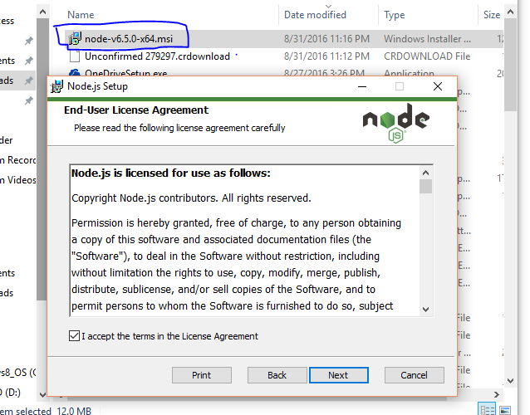

1. Select the npm package manager feature.

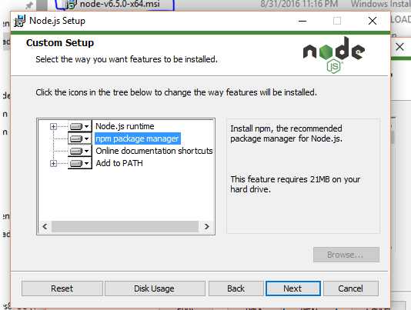

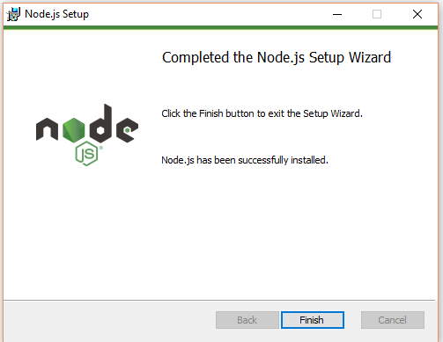

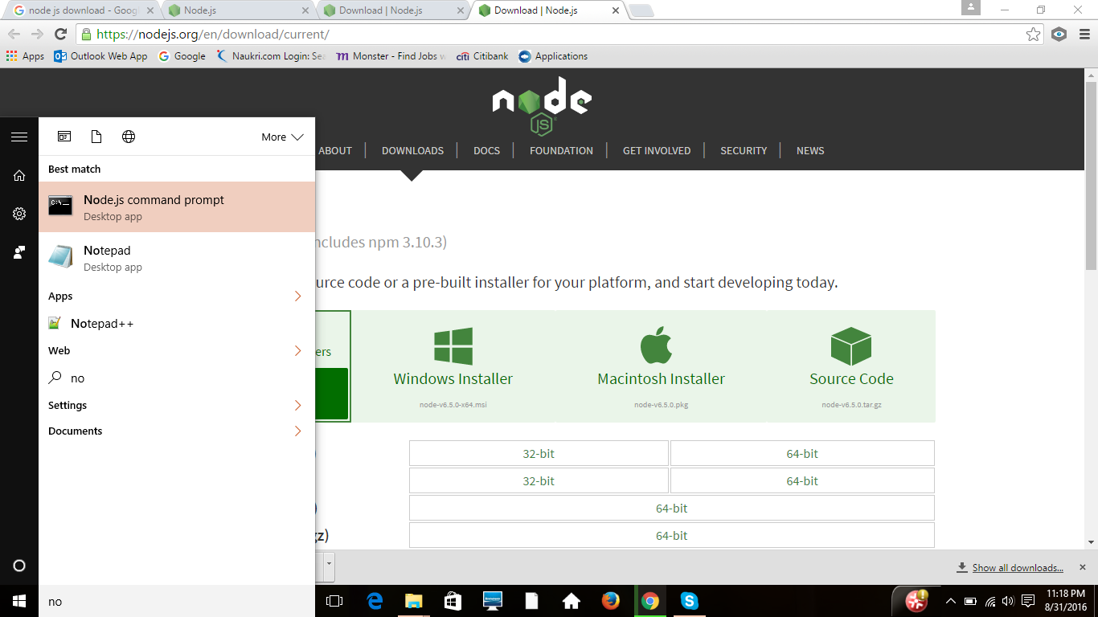

1. To verify your installation, Please type‘**node –v’/’node --version’**in the command prompt which displays you the node version that is installed.

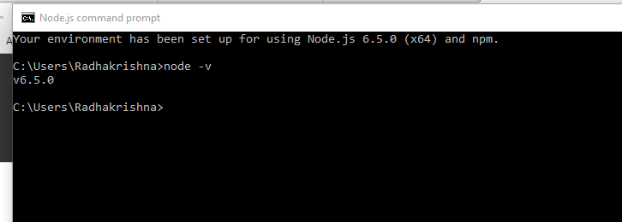

### PROTRACTOR INSTALLATION

Below are the steps for installation:

To install globally, please type the command” **npm install –g protractor**” in command prompt.

The above command will install protractor and make it available globally.

Path may look like C:\Users\User_name\AppData\Roaming

**Note**: if you are not able to view the AppData folder, request you to view the hidden folders.

C:\Users\Radhakrishna\AppData\Roaming>npm install -g protractor

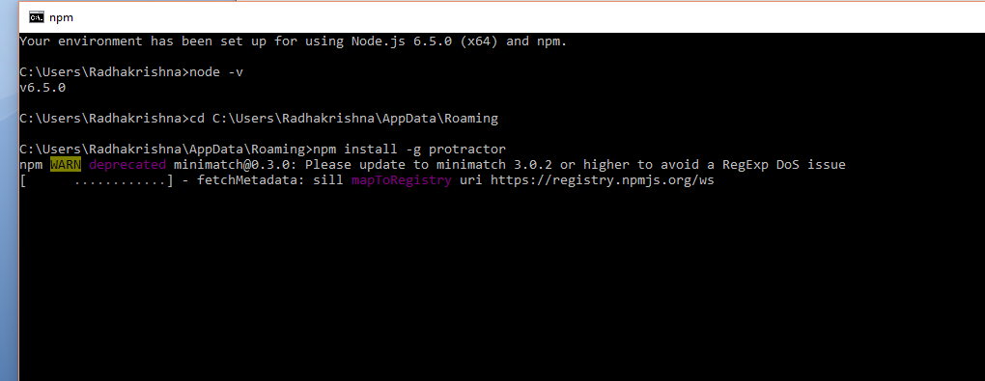

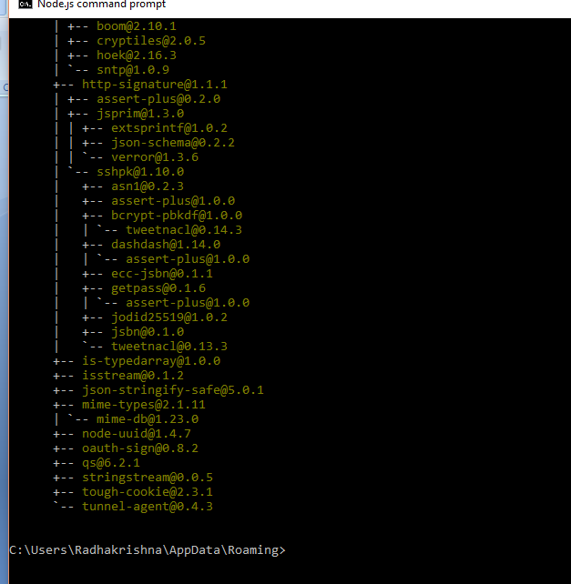

Once that is done, confirm by typing **'protractor --version'** in the command prompt which will show you the protractor version that is installed.

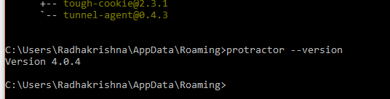

To update the selenium webdriver, please type the command **'webdriver-manager update'** in command prompt.

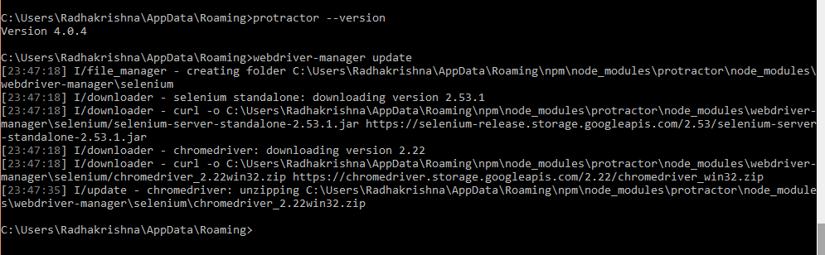

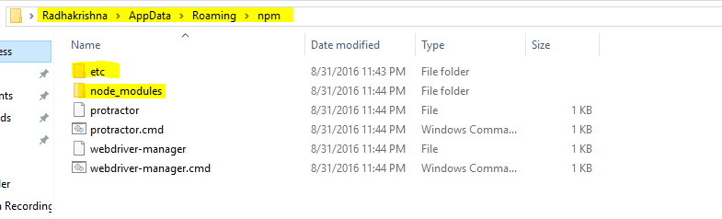

Now start up a server, please type the command **'webdriver-manager start'** in command prompt.

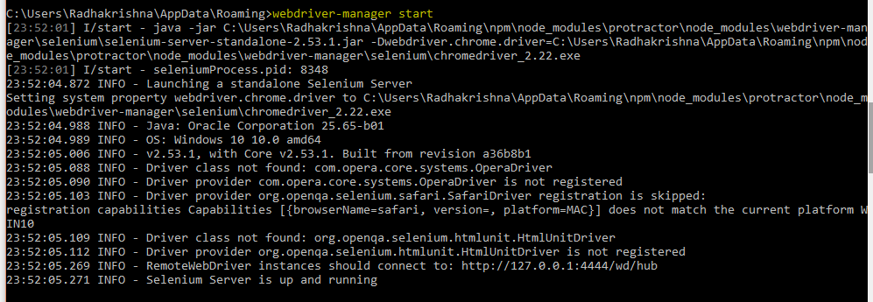

To Install Jasmine HTML reports, Open other nodejs command prompt and run the below cmd

**npm install protractor-jasmine2-html-reporter** or **npmi jasmine-allure-reporter**

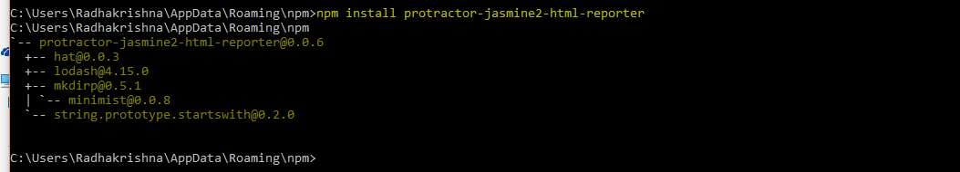

OR

Install jasmine html report in project folder structure as below

In command prompt: cd D:\Protractor Stuff\protractor_project\node_modules

**npm install protractor-jasmine2-html-reporter**

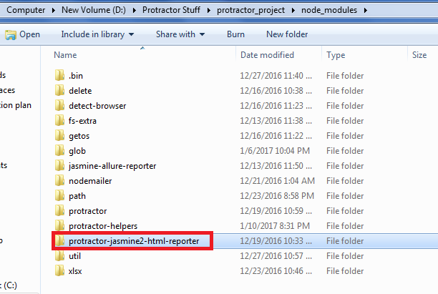

Generating allure reports (<https://www.npmjs.com/package/jasmine-allure-reporter>)

**npm i jasmine-allure-reporter**

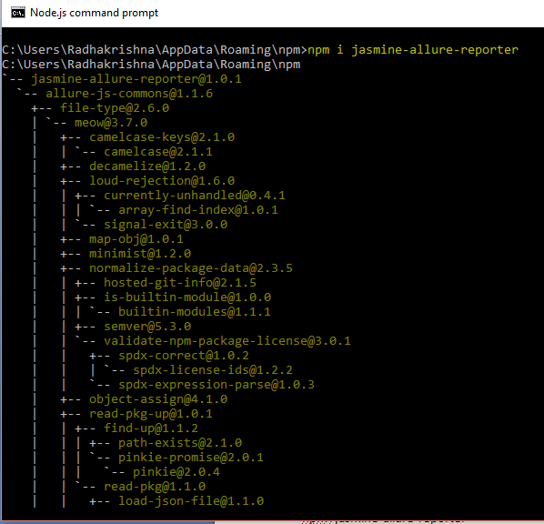

OR

Install allure reports in your project folder structure (Ex: D:\Protractor Stuff\protractor_project\node_modules)

In command prompt : cd D:\Protractor Stuff\protractor_project\node_modules

**npm i jasmine-allure-reporter**

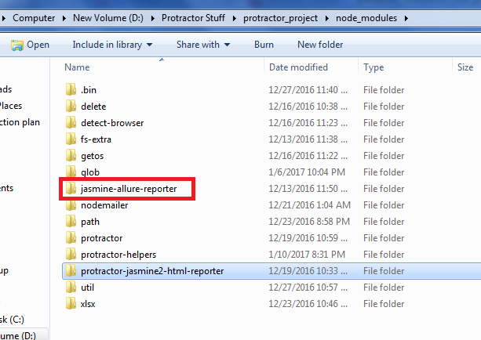

**MAVEN INSALLATION**

To setup Maven to our project, below are the steps for installation:

Download MVN and Set the Environment variable

%M2_HOME% :- C:\Users\Radhakrishna\AppData\Roaming\npm\apache-maven-3.3.9-bin\apache-maven-3.3.9

Path:-%M2_HOME% \bin

**Set Environment variables as below:**

* **USER VARIABLES:-**

**JAVA_HOME** = C:\Program Files\Java\jdk1.8.0_92

**PATH** = C:\Program Files\Microsoft VS Code\bin;C:\Users\jt\AppData\Roaming\npm

* **SYSTEM VARIABLES:-**

**CLASSPATH** = C:\Program Files\IBM\WebSphere MQ\java\lib\com.ibm.mqjms.jar;C:\Program Files\IBM\WebSphere MQ\java\lib\com.ibm.mq.jar;%JAVA_HOME%\lib

**JAVA_HOME** = C:\Program Files\Java\jdk1.8.0_92

**JMETER_HOME** = C:\Jmeter

**LIB** = C:\Program Files\IBM\WebSphere MQ\tools\lib

**M2_HOME** = C:\Users\jt\AppData\Roaming\npm\apache-maven-3.3.9

**NODE_PATH** = C:\Users\jt\AppData\Roaming\npm\node_modules

**PATH** = C:\ProgramData\Oracle\Java\javapath;C:\Program Files\IBM\WebSphere MQ\java\lib;C:\oraclexe\app\oracle\product\10.2.0\server\bin;%SystemRoot%\system32;%SystemRoot%;%SystemRoot%\System32\Wbem;%SYSTEMROOT%\System32\WindowsPowerShell\v1.0\;C:\Program Files\nodejs\node_modules\npm;C:\Users\jt\Downloads\galen-bin-2.3.0;C:\Program Files\Skype\Phone\;C:\Program Files\IBM\WebSphere MQ\bin;C:\Program Files\IBM\WebSphere MQ\tools\c\samples\bin;C:\JMeter\bin;C:\Users\jt\AppData\Roaming\npm\apache-maven-3.3.9\bin;C:\Program Files\Java\jdk1.8.0_92\bin;C:\Program Files\Java\jre1.8.0_92\bin;C:\Program Files\nodejs\

**PROJECT FOLDER:**

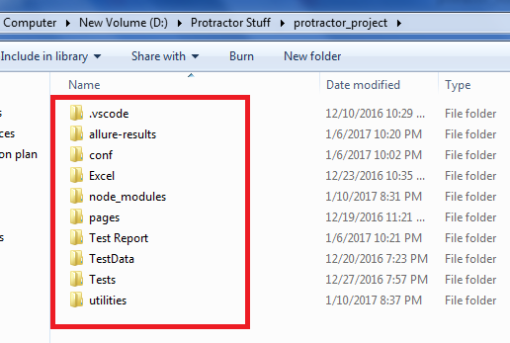

Copy the allure report folder from npm folder and paste it in C:\Users\Radhakrishna\AppData\Roaming\npm\node_modules\protractor-jasmine2-html-reporter

(Maven executes with the help of pom.xml)

OR

Copy “jasmine-allure-reporter” from **D:\Protractor Stuff\protractor_project\node_modules** and paste in **D:\Protractor Stuff\protractor_project\node_modules\protractor-jasmine2-html-reporter** as shown below

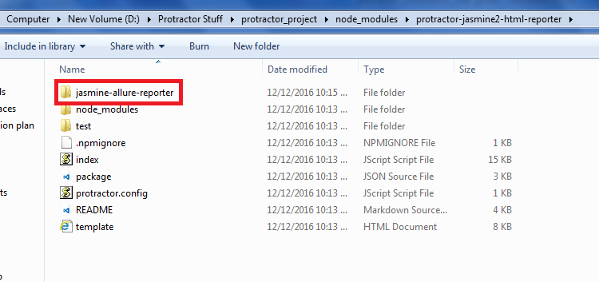

Go to command prompt and run the blow command after every test execution to generate index.html result report file

C:\Users\Radhakrishna\AppData\Roaming\npm\node_modules\jasmine-allure-reporter >**mvn site -Dallure.results_pattern=allure-results**

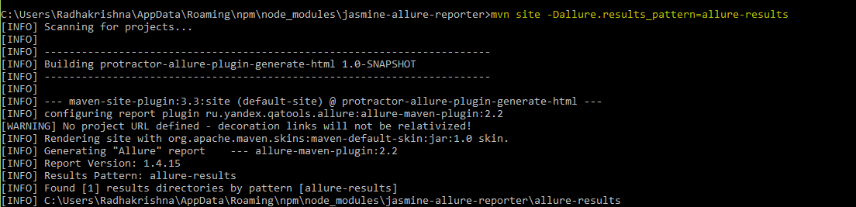

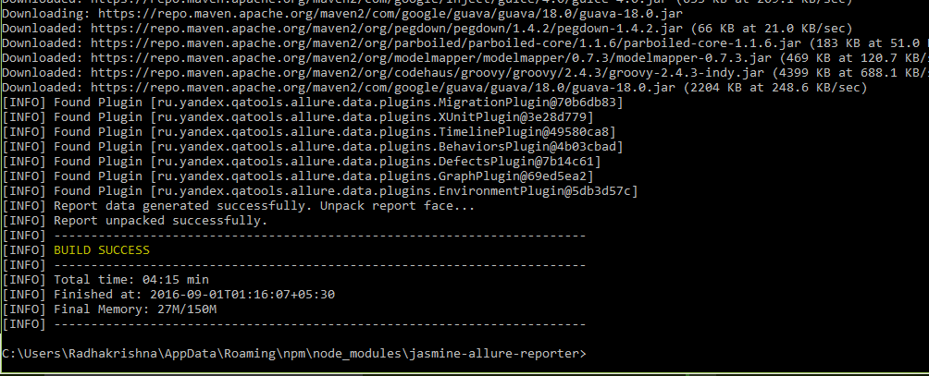

OR

Go to command prompt and run the below command after every test execution to generate index.html result report file

D:\Protractor Stuff\protractor_project\node_modules\jasmine-allure-reporter>**mvn site -Dallure.results_pattern=allure-results**

Before execute above command make sure “**allure-results**” folder is available in “**D:\Protractor Stuff\protractor_project\node_modules\jasmine-allure-reporter”**

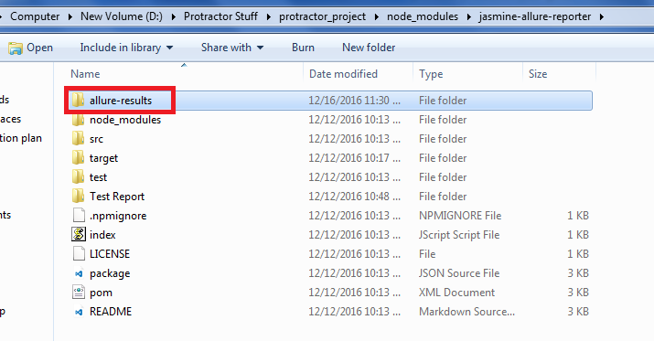

Once you are ready with your test cases and configuration file, the next step is to execute the test and see the results. Please follow below step to execute the tests.

To run the conf file, Please type the command” **protractor conf.js**” in command prompt

Example:-C:\Users\radhakrishna\AppData\Roaming\npm> protractor conf.js

**RESULTS:**

D:\Protractor Stuff\protractor_project\node_modules\jasmine-allure-reporter\target\site\allure-maven-plugin\index.html

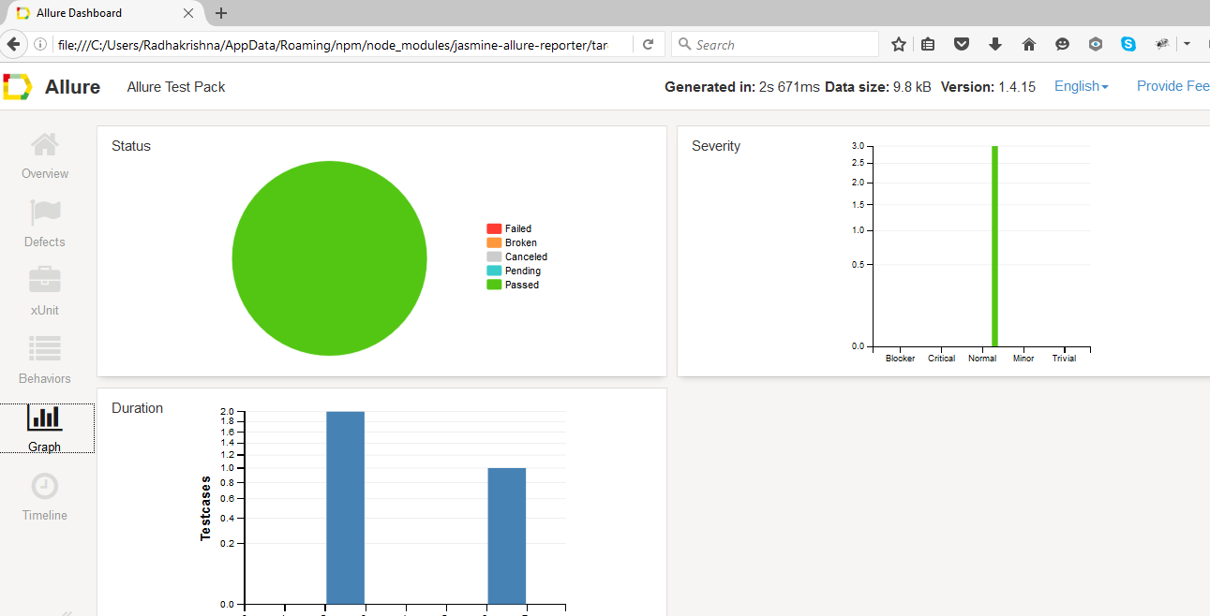

**SCREENSHOTS FOR PROJECT FOLDER**



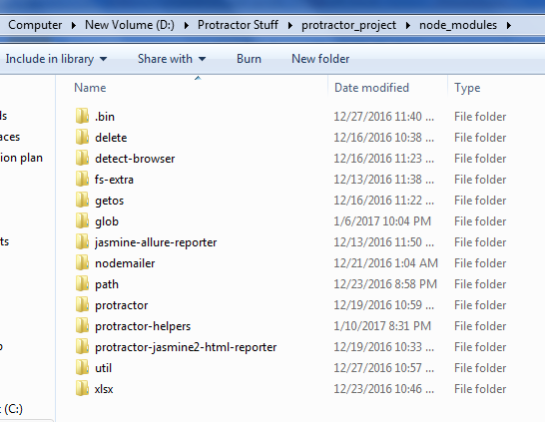

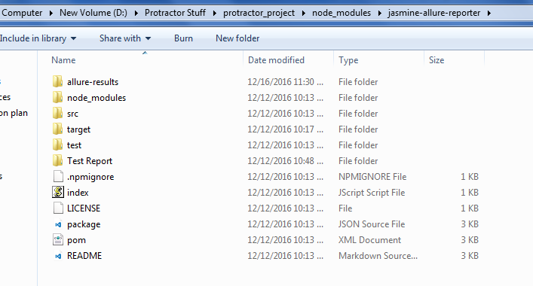

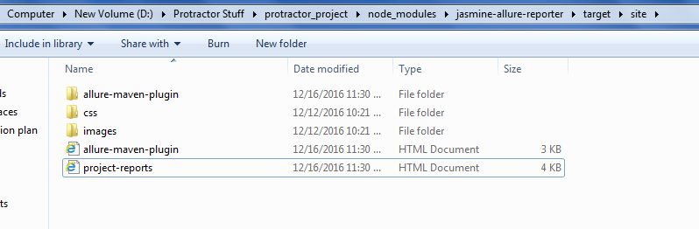

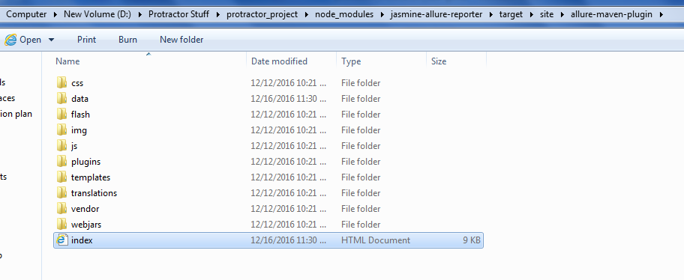

**Install below methods under node_modules when you are executing the script through VS Code tool (D:\Protractor Stuff\protractor_project\node_modules) :**

delete

detect-browser

fs-extra

getos

glob

nodemailer

path

protractor-helpers

util

xlsx

and also, copy app.js and past in **D:\Protractor Stuff\protractor_project ---- >>> not required**

**PROTRACTOR INTEGRATION WITH SELENIUM:**

* **Protractor plugin in eclipse:**
* Go to help🡪marketplace
* Search for **tern.java**
* Install **Tern Eclipse IDE** and accept the license

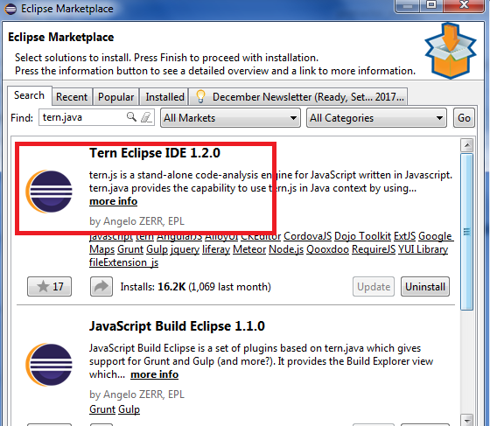

* **Now create a project in eclipse:**
* Create new java project and remove all jar files, JRE System library from build configuration and also src folder

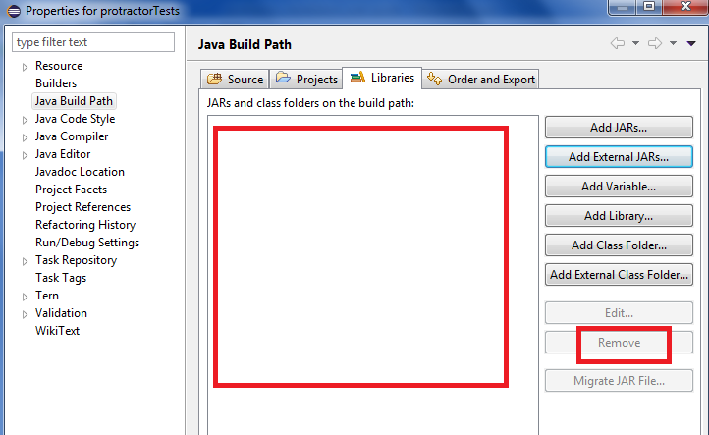

* Copy all protractor files under project created in eclipse

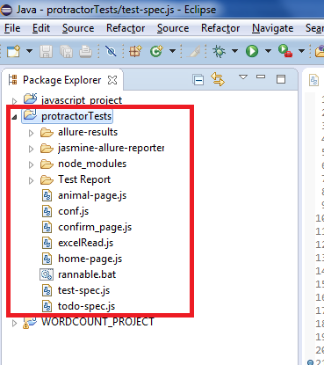

* Right click on project
* Mouse hover to configure and click on **convert to Tern project**

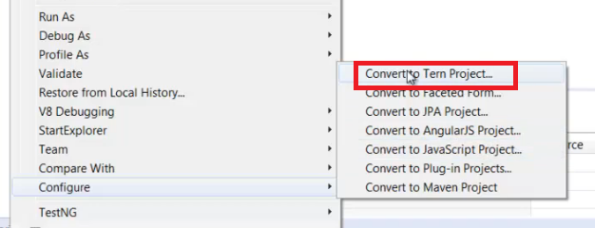

When you **convert to Tern project**, automatically the below window should come up i.e. the protractor is successfully installed in eclipse

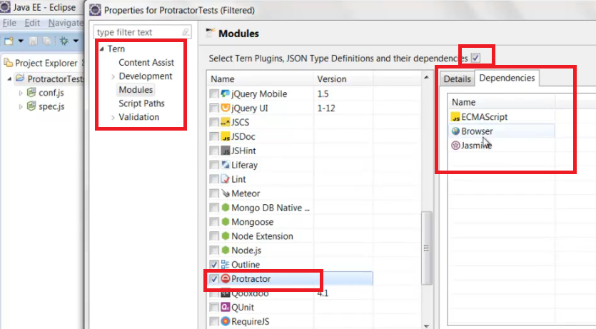

If not, do the below steps:

Goto window 🡪preferences, you can see Tern on left side pane

Select Repository under Tern and select Protractor in right pane as shown below

Make sure dependencies check box is checked

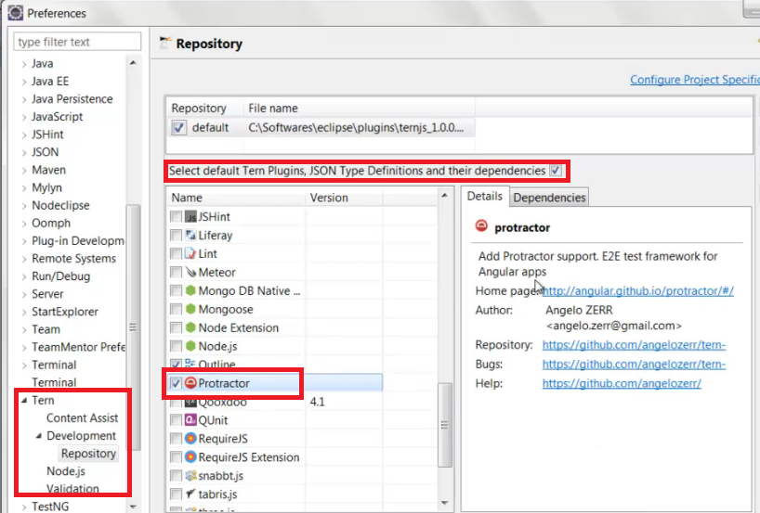

**Run Script:**

Open notepad and type “**protractor conf.js**” and save as runner.bat file in project folder (D:\Protractor Stuff\protractor_project\conf\runner.bat)

In eclipse, click Run As🡪External tools configurations…

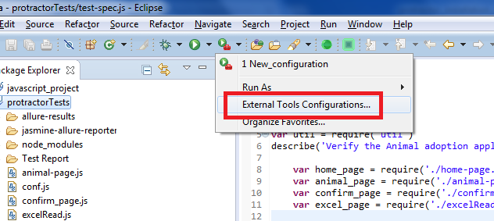

Select program on left pane and click on New launch configuration

Enter the Location and Working directory as below 🡪 Apply 🡪Run

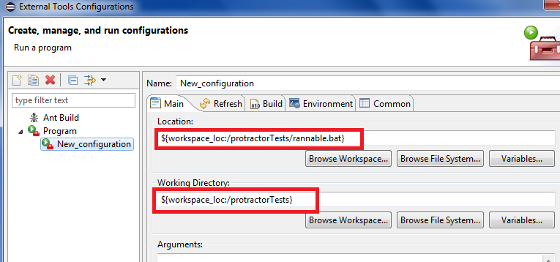

**PROTRACTOR INTEGRATION WITH JENKINS:**

* Download jenkins “**jenkins.war**” file from [**https://jenkins-ci.org**](https://jenkins-ci.org)
* Install jenkins using the command **java –jar jenkins.war**

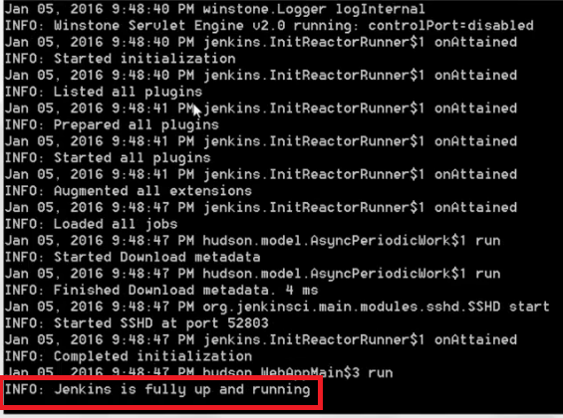

* Open jenkins in browser **“https”//localhost:8080/jenkins”**

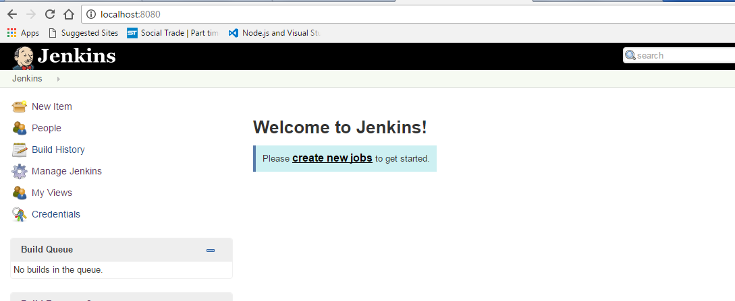

* Click on manage jenkins link and click Global Tool Configuration
* Configure the java path and maven as shown below

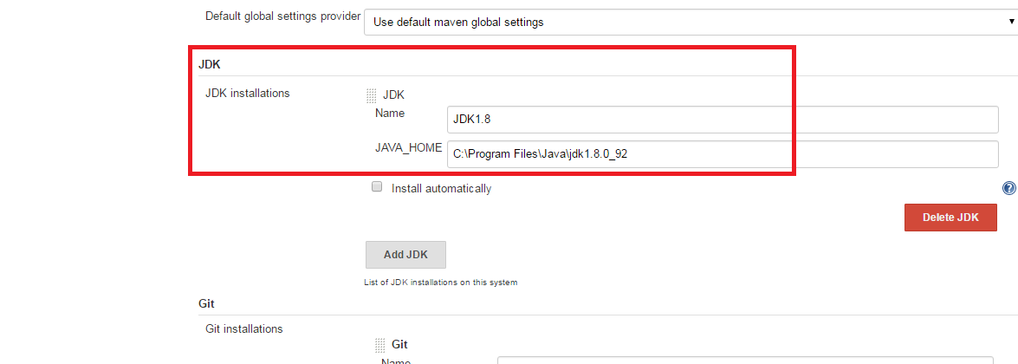

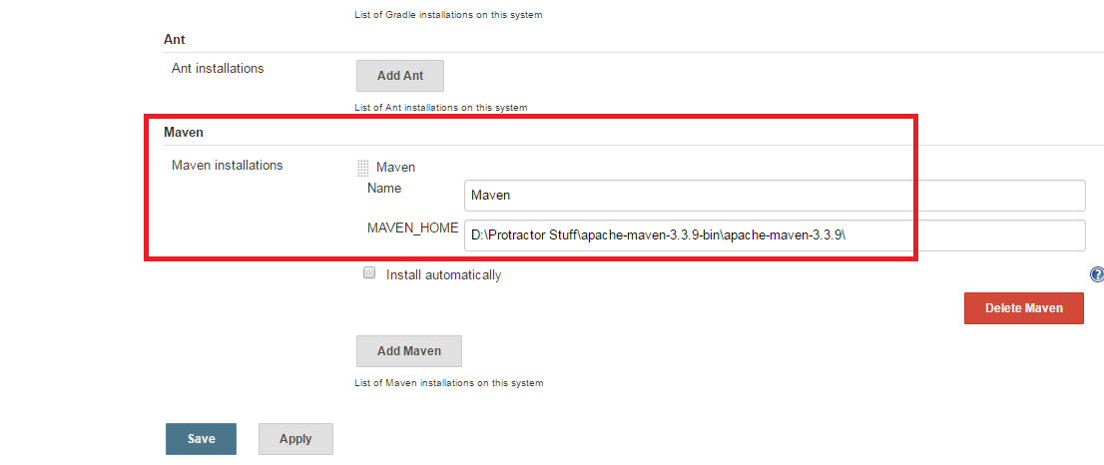

* Click apply and save
* Create new job in jenkins home page

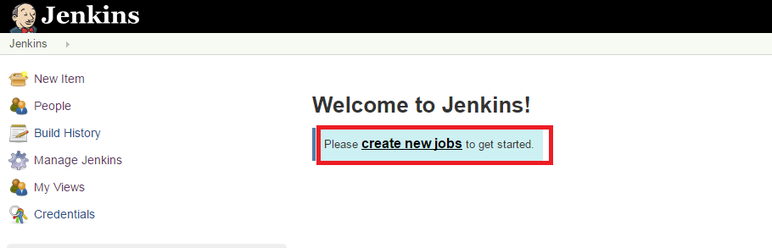

* Enter job name and click on Multi configuration project and click OK

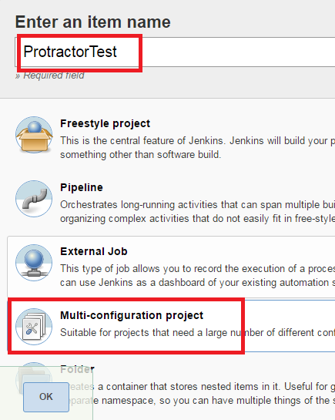

* In configuration, select **execute windows batch command** in Build and enter the command

D:

cd D:\Protractor Stuff\protractor_project\conf

protractor conf.js

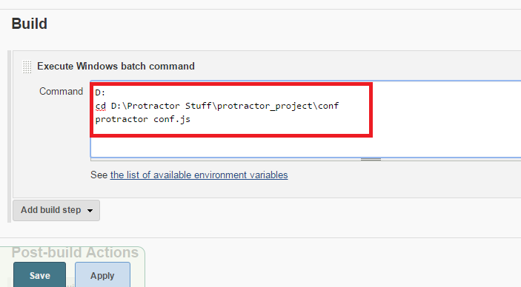

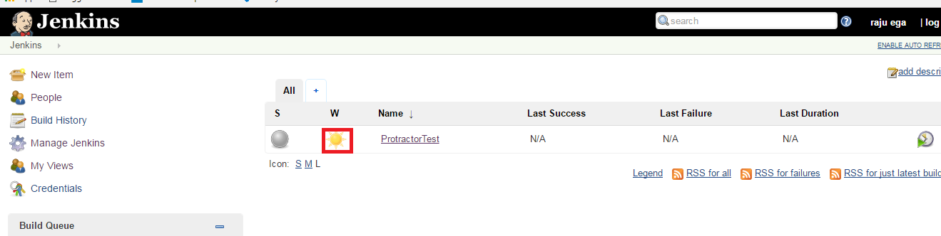

**NOTE:**

If all the builds are successful, you can see weather report symbol as shown below. If they are any failures you can see cloud symbol

* Schedule a build for a job which we have created

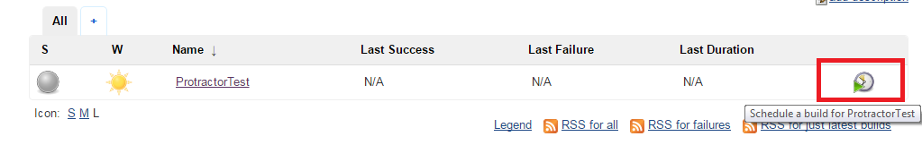

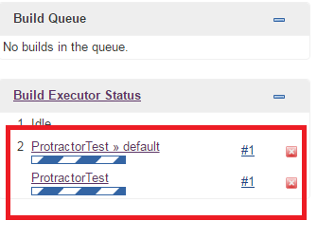

* Click on project build and click Build now

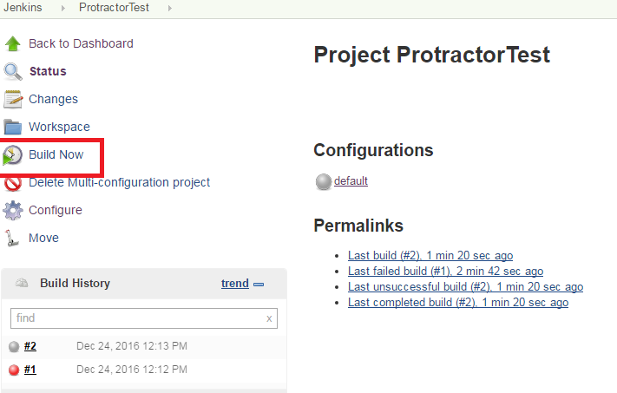

* Click on build #3 to see the console output

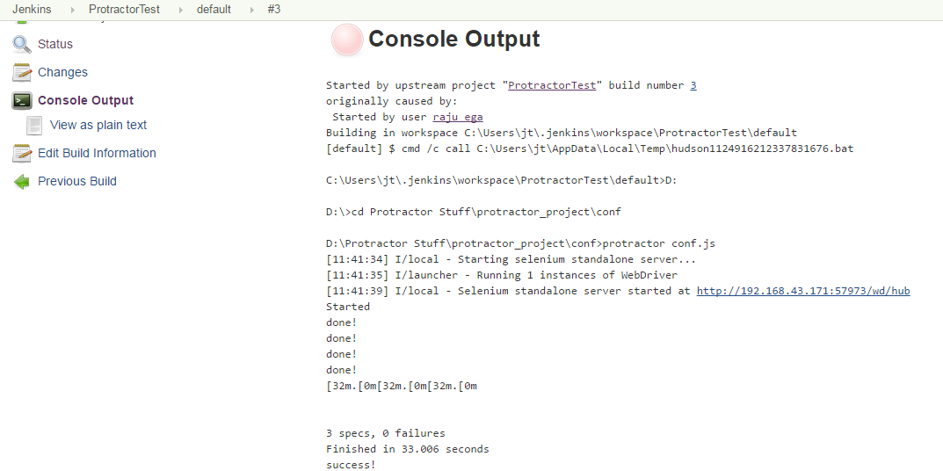

**DEBUG/RUN PROTRACTOR TESTS THROUGH VISUAL STUDIO CODE:**

1. Open VS Code tool and open project folder (File🡪Open Folder🡪select Project root folder🡪click OK)

Ex: Project root folder: D:\Protractor Stuff\protractor_project

2. Click on debug view on left side bar

3. Click on the Configure gear icon at the top of the Debug view to create a default launch.json configuration file

4. Select **Node.js** as the Debug Environment

5. The new launch.json file is created in a VS Code specific .vscode folder in root of your workspace (D:\Protractor Stuff\protractor_project\.vscode)

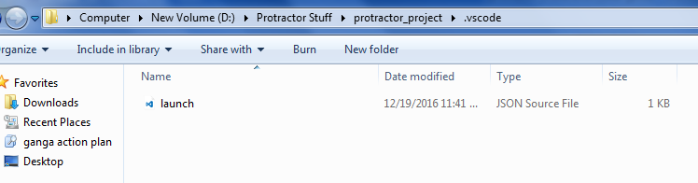

Change the paths as below:

"**program**": "D:/Protractor Stuff/protractor_project/node_modules/protractor/built/cli.js",

"**cwd**": "${workspaceRoot}",

"**args**": [ "D:/Protractor Stuff/protractor_project/conf.js" ]

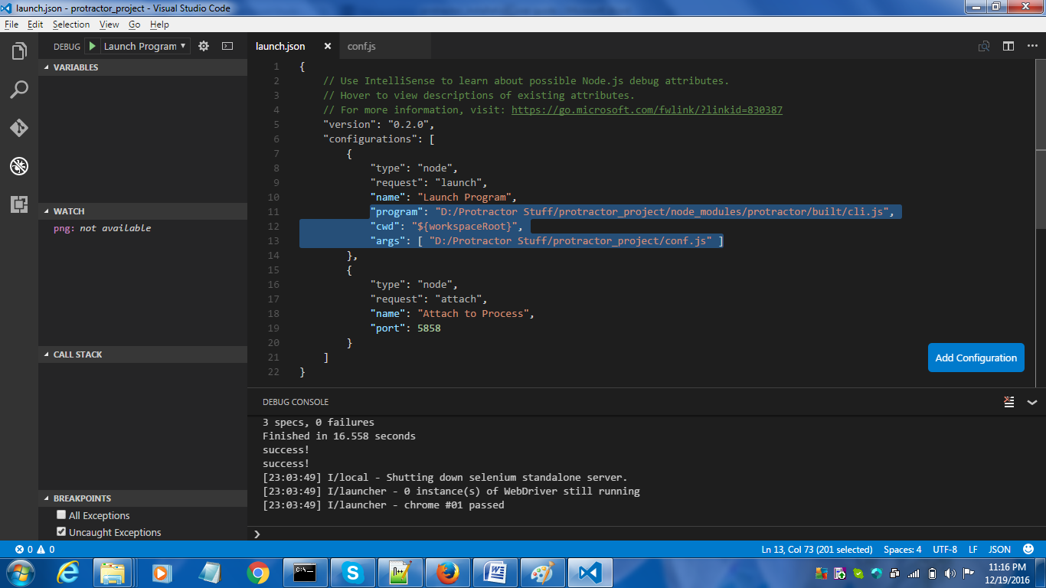

**EXCEL READ:**

Install xlsx “**npm install xlsx**”

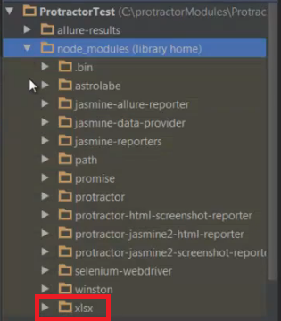

var XLSX = require('xlsx')

var workbook = XLSX.readFile('D:/Protractor Stuff/protractor_project/Excel/testdata.xlsx');

var first_sheet_name = workbook.SheetNames[0];

var address_of_cell = 'A1';

var worksheet = workbook.Sheets[first_sheet_name];

var desired_cell = worksheet[address_of_cell];

var desired_value = desired_cell.v;

**PROJECT JS FILES:**

* Under conf folder:



* Under pages folder:



* Under Test Data folder:



* Under Tests folder:



* Under utilities folder:



* Under Excel folder:



* Under Test Report folder:

